Chapter test with answers
Chapter 4 Chemical reactions
Time permitted: 30 minutes
 | Section | Number of questions | Marks available
A | Multiple choice | 15 | 15
B | Short answer | 5 | 15
 | Total |  | 30
Scale:
A+ | 29–30 | A | 26–28 | B | 23–25 | C | 19–22 | D | 15–18 | E | 9–14 | UG | 0–8
Section A Multiple choice (15 marks)
Section A consists of 15 questions, each worth one mark. Each question has only one correct answer. Circle the correct answer. Attempt all questions. Marks will not be deducted for incorrect answers. You are advised to spend no more than 15 minutes on this section.
1 Which of the following is not an example of a chemical reaction?
A An iron nail rusting
B Lighting a match
C Respiration
D Sugar crystals dissolving in water
2 A student performed the ‘pop’ test by holding a lit taper over the top of a closed test tube containing hydrogen gas. When the gas was released, a loud ‘pop’ was heard and small clear, colourless droplets of liquid were formed at the mouth of the test tube. These were found to be water. The correct word equation to represent this reaction is:
A Hydrogen + oxygen 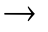 water
B Hydrogen + heat water + sound
C Hydrogen water + sound
D Hydrogen water
3 What does (aq) mean when written in a chemical equation?
A Water is a reactant in the chemical reaction.
B Water is a product in the chemical reaction.
C All of the substances are dissolved in water.
D The substance directly before it is a solution.

For questions 4 and 5 refer to the unbalanced chemical equation below:
Mg + HCl → MgCl2 + H2
4 Which of the following shows the correct coefficients for the balanced chemical equation?
A 1:1:1:1
B 1:2:1:2
C 1:2:1:1
D 2:4:2:2
5 Which of the following statements is false?
A The coefficients represent the particle ratios of each substance.
B The coefficients represent the mass ratios of each substance (g, kg, etc.).
C The coefficients represent the mole ratios of each substance.
D The coefficients represent the volume ratios of each substance.
6 Which of the following statements is false?
A Chemicals react to achieve stability.
B More energy is required to break bonds than to re-form bonds in a chemical reaction.
C Mass is conserved in chemical reactions.
D Bonds are broken and new bonds form in chemical reactions.
For questions 7 and 8 refer to the table below.
Metal | Reacts with  water | Reacts with  dilute acid | Reacts with  oxygen
Ag |  |  | ✓
Ca | ✓ | ✓ | ✓
Al |  | ✓ | ✓
Pb |  | ✓ | ✓
Cu |  |  | ✓
Mg |  | ✓ | ✓
Au
K | ✓ | ✓ | ✓
7 Which is the least reactive metal?
A Ag
B Au
C Ca
D K

8 Which metal would most likely need to be stored in oil so it is not in contact with the air?
A K
B All except Au
C Ag
D None
9 If energy does not need to be added to a reaction to make it occur at room temperature, then it can be referred to as a:
A reversible reaction.
B combustion reaction.
C spontaneous reaction.
D non-spontaneous reaction.
10 Which of the following does not include spectator ions in the equation?
A Word equation
B Balanced chemical equation
C Ionic equation
D Net ionic equation
11 A student adds a chemical to water and stirs it with a thermometer until it has dissolved. She correctly deduces that it is endothermic. What observation could she have made to deduce this?
A The chemical dissolved (it would not dissolve if it were exothermic).
B The temperature did not change, hence energy is required to be added.
C The temperature of the solution was lower than the initial temperature of the water.
D The temperature of the solution was higher than the initial temperature of the water.
12 Absolute zero occurs at:
A 0 K
B 0°C
C 273 K
D 273°C
13 Water has a specific heat capacity of 4.18 J/K/g and ethanol has a specific heat capacity of 2.46 J/K/g. Which is true?
A Water requires more energy to raise the temperature by 1 K than the same mass of ethanol does.
B Water requires less energy to raise the temperature by 1 K than the same mass of ethanol does.
C Ethanol is always hotter than water.
D 2 g of ethanol will have a higher specific heat capacity than water.

14 A dietician used the phrase ‘Food is fuel! It provides us with energy’. Which of the following reactions does this describe?
A Combustion
B Respiration
C Both A and B
D None of the above
15 Which of the following demonstrates that complete combustion has occurred/is occurring?
A The flame of a Bunsen burner is blue.
B The flame of a Bunsen burner is orange.
C The bottom of a beaker is black after being heated with a spirit burner containing a fuel.
D Limewater does not turn cloudy when the gas released upon burning a fuel is bubbled through it.

Section B Short answer (15 marks)
Section B consists of five questions. Write your answers in the spaces provided. You are advised to spend 20 minutes on this section.
1 Copper(II) nitrate is heated in a crucible over a Bunsen burner, forming solid copper(II) oxide, nitrogen dioxide and oxygen gas.
a Write a balanced chemical equation for this reaction. (1 mark)
Answer: 2Cu(NO3)2(s) 2CuO(s) + 4NO2(g) + O2(g)
b Is this an exothermic or endothermic reaction? Explain your answer.
(2 marks)
Answer: Thermal decomposition is an endothermic reaction as heat energy is required to break the chemical bonds in the copper(II) nitrate.
2 Draw an energy profile diagram to help you describe endothermic reactions. Include the following on your diagram: enthalpy, reactants, products, ΔH, Hreactants, Hproducts (3 marks)
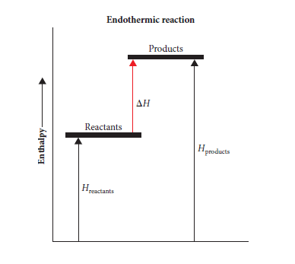
Answer: In an endothermic reaction energy is absorbed, since the energy of the reactants is less than the energy of the products. ΔH is positive as Hproducts – Hreactants is positive.
3 a Define specific heat capacity. (1 mark)
Answer: Specific heat capacity is the heat required to increase the temperature of 1 g of a substance by 1 K.
b 26.8 kJ of heat was used to increase the temperature of 180 g of a substance from 22°C to 57.6°C. Determine the specific heat capacity of the substance. (2 marks)
Answer:
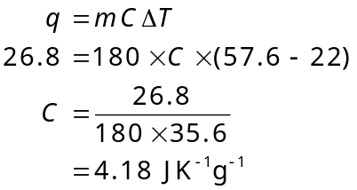

4 a Draw a scientific diagram of the equipment you would use in the laboratory to determine how much heat is released by the complete combustion of a fuel such as ethanol. (1 mark)
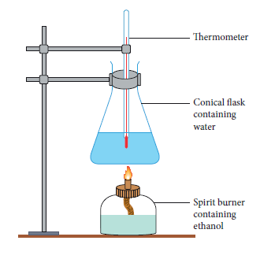
b Outline at least one problem associated with this equipment set-up, and a possible solution to the problem. (2 marks)
Answer: Not all of the heat generated by the fuel is being used to heat the water. Some is heating the air around the apparatus, the conical flask, and the tripod and gauze. A draft excluder could be used to surround the apparatus and the conical flask could be clamped and suspended over the flame so the tripod and gauze were not needed.
5 A sodium hydroxide solution is added to a magnesium chloride solution. Solid magnesium hydroxide is formed with another clear solution.
a Write a balanced chemical equation for this reaction. (1 mark)
Answer: 2NaOH + MgCl2 Mg(OH)2(s) + 2NaCl
b Write an ionic equation for this reaction. (1 mark)
Answer: 2Na+ + 2OH– + Mg2+ + 2Cl– Mg(OH)2(s) + 2Na+ + 2Cl–
c Write a net ionic equation for this reaction. (1 mark)
Answer: Mg2+ + 2HO– Mg(OH)2(s)
End of test (30 marks)

